# Hadoop编译

编译方法见相关编译文档



# 出现的问题





启用kerberos要用编译包含native的版本

<http://hadoop.apache.org/docs/stable/hadoop-project-dist/hadoop-common/NativeLibraries.html>

# Kerberos安装

## 在KDC节点上安装 krb5-server

yum install -y krb5-server krb5-workstation openldap

### 配置krb5.conf

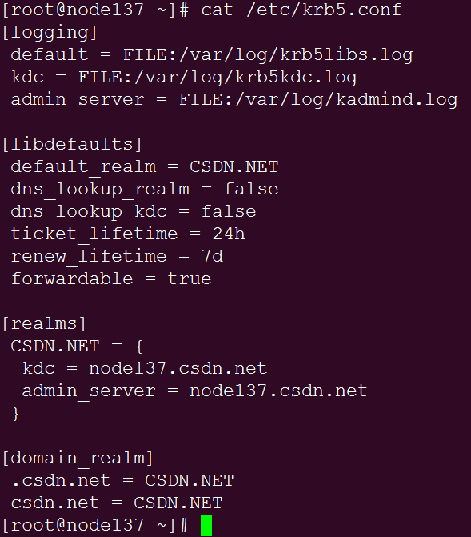

### 配置kdc.conf

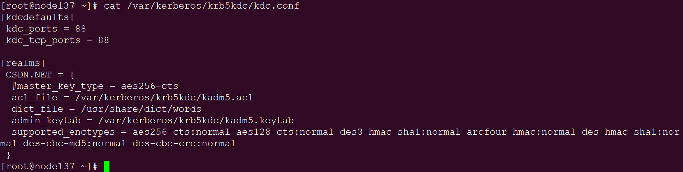

### 配置kadm5.acl

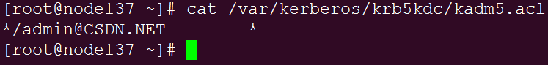

### 关闭SElinux

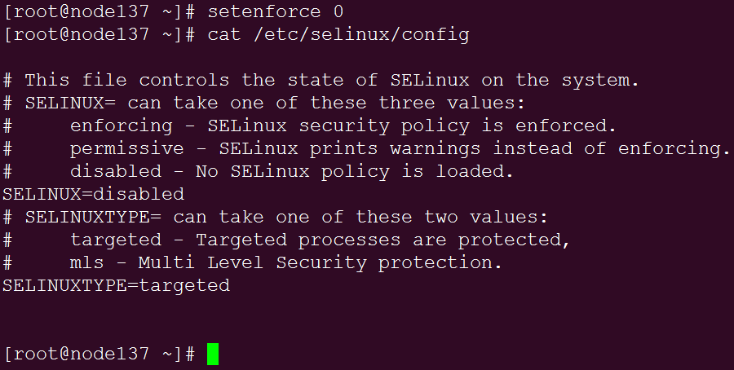

### 初始化数据库

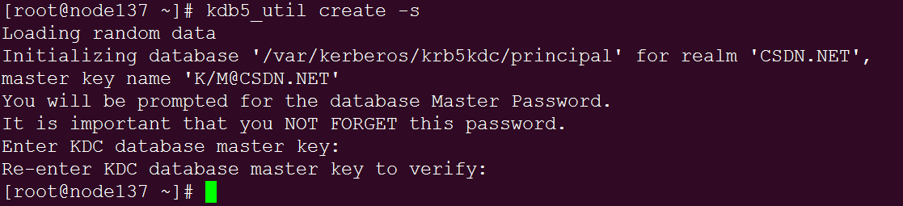

密码：csdn.net

### 启动服务

chkconfig krb5kdc on

chkconfig kadmin on

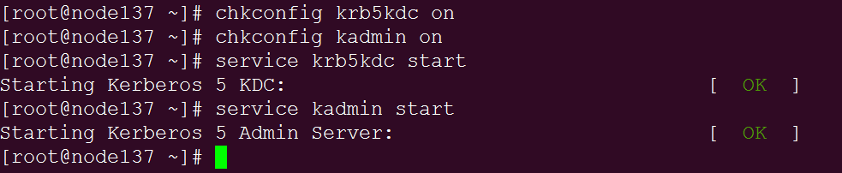

### 创建管理员用户admin

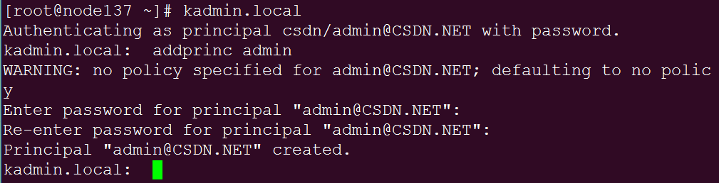

密码：csdn.net

## 在Client节点上安装krb5‐devel、krb5‐workstation

yum install krb5-devel krb5-workstation –y

### 将server节点的krb5.conf 同步到客户端

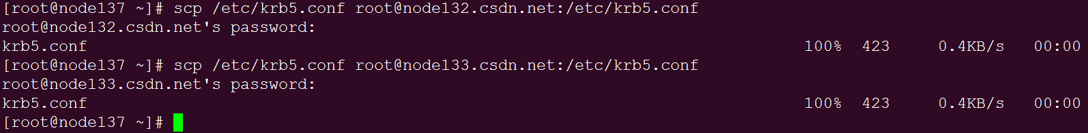

### 验证客户端

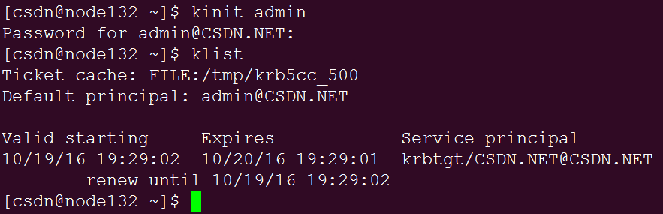

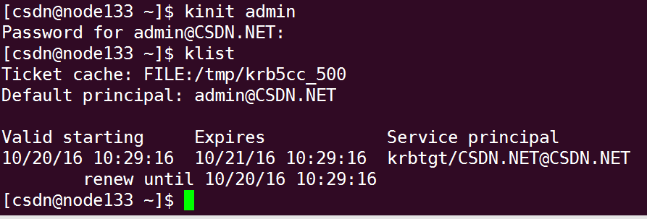

# HDFS Enable Kerberos

<http://hadoop.apache.org/docs/stable/hadoop-project-dist/hadoop-common/SecureMode.html>

## 创建HDFS用户

kadmin.local -q "addprinc -randkey hdfs/node137.csdn.net@CSDN.NET"

kadmin.local -q "addprinc -randkey hdfs/node132.csdn.net@CSDN.NET"

kadmin.local -q "addprinc -randkey hdfs/node133.csdn.net@CSDN.NET"

kadmin.local -q "addprinc -randkey HTTP/node137.csdn.net@CSDN.NET"

kadmin.local -q "addprinc -randkey HTTP/node132.csdn.net@CSDN.NET"

kadmin.local -q "addprinc -randkey HTTP/node133.csdn.net@CSDN.NET"

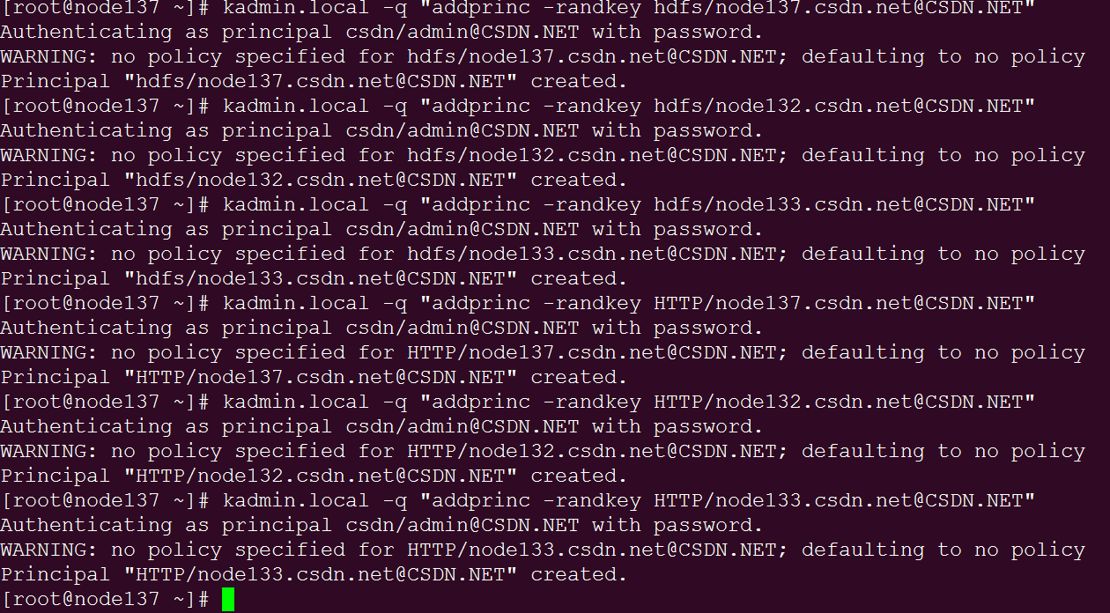

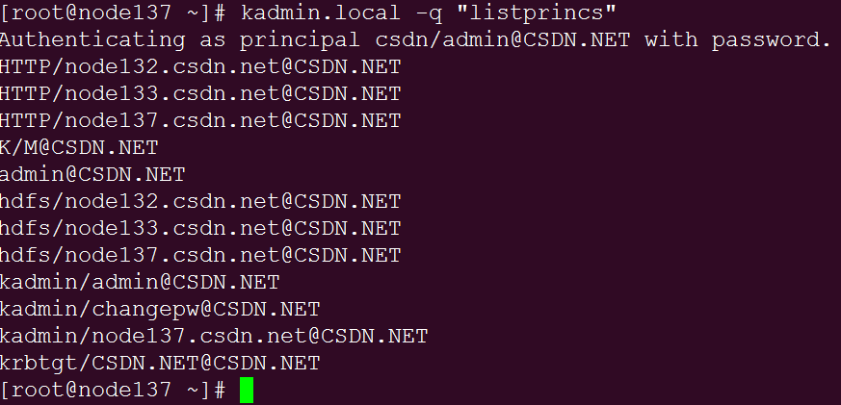

## 生成keytab文件

[root@node137 kerberos]# bash generate_hdfs_ktb.sh CSDN.NET

kadmin.local -q "xst -k hdfs.service.keytab hdfs/node132.csdn.net@CSDN.NET"

scp hdfs.service.keytab root@node132.csdn.net:/etc/security/keytabs/

kadmin.local -q "xst -k hdfs.service.keytab hdfs/node133.csdn.net@CSDN.NET"

scp hdfs.service.keytab root@node133.csdn.net:/etc/security/keytabs/

kadmin.local -q "xst -k hdfs.service.keytab hdfs/node137.csdn.net@CSDN.NET"

scp hdfs.service.keytab root@node137.csdn.net:/etc/security/keytabs/

## 安装JSVC

wget <https://archive.cloudera.com/cdh5/redhat/6/x86_64/cdh/cloudera-cdh5.repo>

yum -y install bigtop-utils bigtop-jsvc

## 安装JCE

将jce解压出的jar文件复制到$JAVA_HOME/jre/lib/security/路径下

#unzip -o -j -q jce_policy-8.zip -d $JAVA_HOME/jre/lib/security/

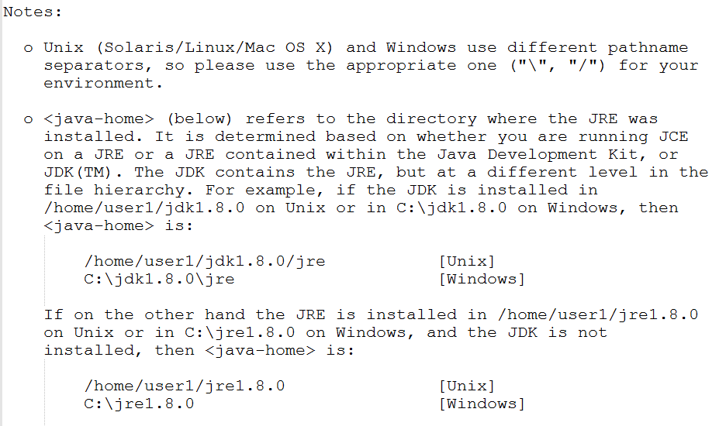

## 配置hadoop-env.sh

export HADOOP_SECURE_DN_USER=hdfs

export HADOOP_SECURE_DN_PID_DIR=/var/run/hadoop-hdfs

export HADOOP_SECURE_DN_LOG_DIR=/var/log/hadoop-hdfs

export JSVC_HOME=/usr/lib/bigtop-utils

## 配置core-site.xml

## 配置hdfs-site.xml

## 启动NameNode（HDFS用户）

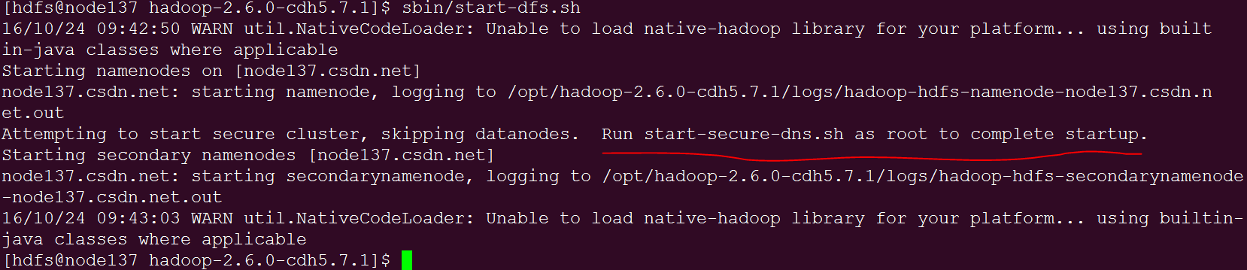

## 启动DataNode（root用户）



# Yarn Enable Kerberos

<http://hadoop.apache.org/docs/stable/hadoop-project-dist/hadoop-common/SecureMode.html#NodeManager>

# 常见问题

## kinit: Ticket expired while renewing credentials

<http://www.cnblogs.com/xiaodf/p/5968178.html>

<http://blog.csdn.net/wulantian/article/details/42173095>

在realms中添加 max_renewable_life 和default_principal_flags

[realms]

CLOUDERA = {

kdc = quickstart.cloudera

admin_server = quickstart.cloudera

max_renewable_life = 7d 0h 0m 0s

default_principal_flags = +renewable

}